# Lab 9: Writing Java Database Applications using the JDBC API (Part 3)

**Objectives**

* Develop an Employee management system for an organization
* Using JTable

**Tool(s)/Software**

* NetBeans IDE

**Description**

This lab requires students to develop a database driven application. The data contains data about employee for an organization. This data can be displayed in the Java application through JTable. Code snippets have been provided and the students are required to view these snippets and develop a fully working application.

**Tasks/Assignments**

Follow the following steps:

1. Create Employees Database that has one table named Employee. Note that Emp ID field is the primary key. After creating the database, insert some sample data.

|  |  |  |  |
| --- | --- | --- | --- |
| **Emp ID** | **Name** | **Department** | **Salary** |
| 1255 | Mohammed | IT | 8500 |
| 1256 | Omar | IT | 9000 |
| 1300 | Lama | HR | 6000 |
| 1310 | Sara | HR | 5900 |

1. Add the required jar/library files

* Download the Jar File “rs2xml.jar” from BlackBoard. This is also available at:
  + <https://sourceforge.net/projects/finalangelsanddemons/files/latest/download>
* Add the Jar file to your project.
  + Right Click on Libraries -> add JAR/Folder then select the “rs2xml.jar” file
* Add the JDBC Driver.
  + Right Click on Libraries -> add Library then choose the appropriate driver

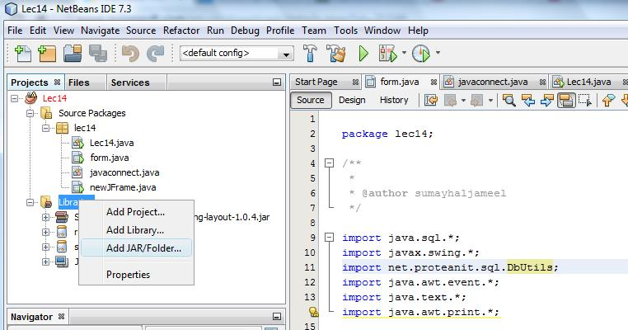

1. Design the interface using Netbeans design tools.
   * Create a new JFrame Form. (EmpTableFrame)

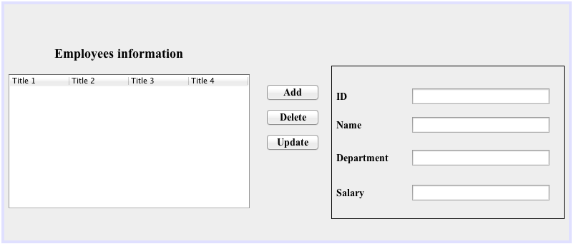

* + Variables Names:

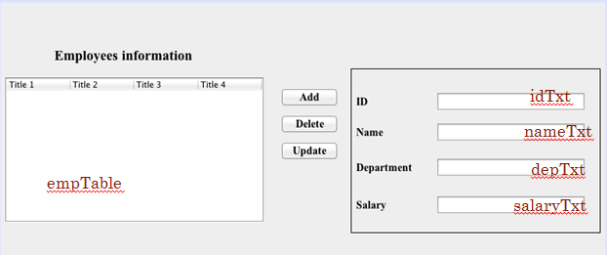

1. Start Coding

* Class EmpTableFrame

* FillTable Method in class EmpTableFrame
* FillTable Method in class EmpTableFrame. To use this statement you need to:
  + add rs2xml.jar
  + import net.proteanit.sql.DbUtils;

* closeDB Method in class EmpTableFrame

* Table Mouse Clicked

Alternative way:

* Add Button

* Delete Button

* Update ButtonA screenshot of a social media post

  Description automatically generated
* **Test The program**

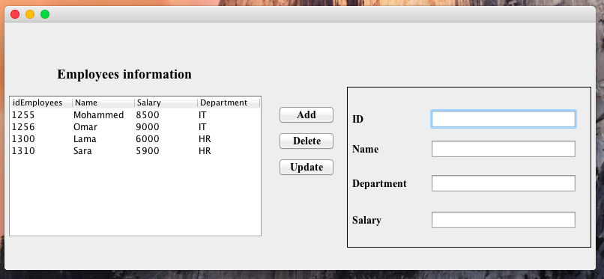

**Deliverables:**

The deliverable for this lab is a working prototype of the employee management system. You should demonstrate your application to your instructor at the end of the lab.